MORE THAN MEETS THE EYE
___________________________________

A Photojournalistic Exposé
of the Global Robot Menace

by

Brad Allen Thompson

More Than Meets the Eye, Part 1

April 22, 2007

An aeronautical tragedy occurred this Saturday, when one of the Navy's esteemed Blue Angels F/A-18 precision-flying jets went down during an air show in South Carolina.

Or so the government would have us believe.

In actuality, the plane that crashed was not a part of the Blue Angels team at all. It was, in fact, a hostile, transformable robot that had entered the hangars of the nearby Marine Corps Air Station the night before the show in order to infiltrate the military ranks.

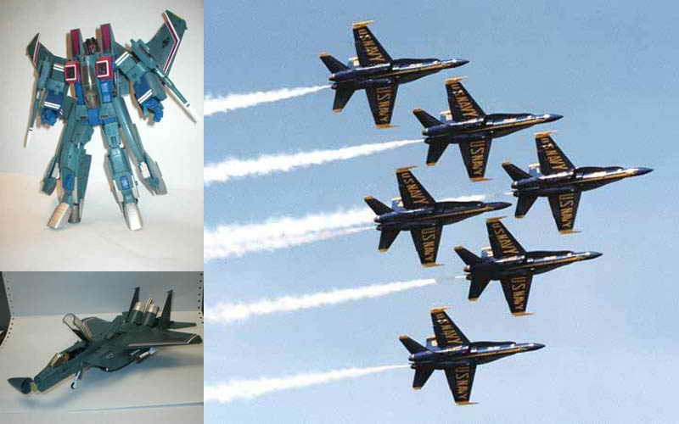
The robot's attempt to transform halfway throughout the air show and slaughter the dozens of patriotic attendees, including several ranking military personnel from the various branches of the armed services, was foiled by the vigilant Navy pilots who, engaging the robot in mid-transformation, destroyed the malicious entity with a barrage of air-to-air missiles and other, highly classified munitions.

Fearful of the panic and chaos sure to greet official confirmation of the existence of sentient, and often hostile, robot invaders from other worlds, the U.S. government quickly publicized a cover story indicating that Saturday's crash was due solely to accident and/or pilot error of indeterminate cause.

But this is not the first time in history that the existence of the machine menace has been deliberately concealed by the United States and other governments.

One of the first cover-ups in modern times was concocted at the behest of the British Crown, which, in 1859, encouraged an English naturalist named Charles Darwin to publish a controversial book entitled The Origin of Species. This work attempted to explain how species of various creatures have evolved over the millennia, bridging the gap between species living today and those who are known to man only by the chance findings of their gargantuan remains.

However, the truth is that the remains studied by Darwin and other naturalists had long been known by government leaders and their advisors not to have been left by creatures of a biological nature. They were actually the remnants of otherworldly robots who had ventured to Earth millions of years ago to wage war against each other upon a young planet still devoid of sentient life.

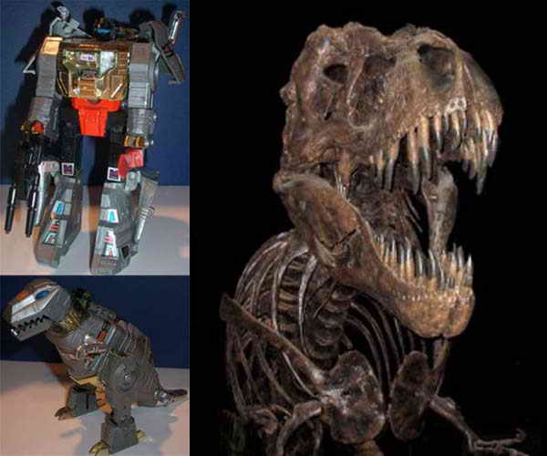
More soon to come...

MORE THAN MEETS THE EYE, PART 2

April 23, 2007

Yesterday evening I presented the first of a series of photojournalistic essays exposing the truth behind a worldwide government conspiracy to conceal the existence of a living, thinking robot menace from outer space.

My first article demonstrated that various world leaders have had knowledge of this peril for at least the past 150 years, and that evidence is mounting that the robots have been integrally involved in global events not only in our relatively recent past, but even stretching tens of millions of years back into prehistory.

Here are some additional examples of the scope of this global conspiracy:

As previously reported, in the middle of the nineteenth century the British government commissioned the publication of the theory of evolution as a means to provide a benign, though false, explanation for the remnants of an ancient race of robot warriors who used the Earth as a battleground millions of years ago.

It was not long after this that the Crown heard tell of possible living descendants of those metal monsters striking fear into the hearts of peasants living near the forested mountains of Eastern Europe. Sending in an advance intelligence-gathering party led by Van Helsing and Harker, the British soon learned of a metal monster preying upon the citizens of Transylvania, said to be capable of changing its form into that of a vampire bat to flit about the night skies, returning to its lair to transform itself into a protective box resembling a coffin.

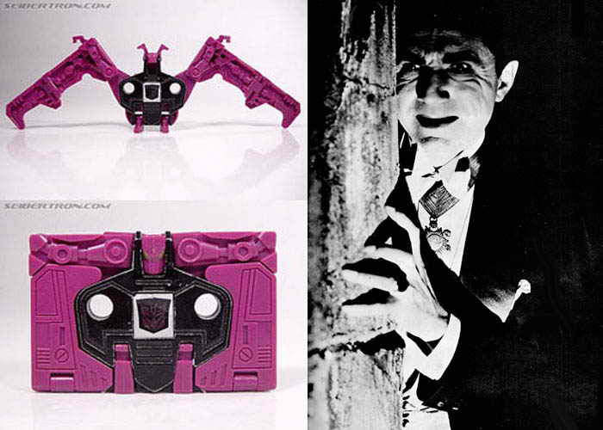

Leading a covert assault force upon the lair of this foul beast, the Van Helsing-Harker team was eventually able to neutralize the foe. However, in keeping with its policy of hiding the true nature of the alien threat from the public's consciousness, the government commissioned Bram Stoker, a Irish novelist, to fictionalize the account of Van Helsing's and Harker's exploits.

The result was the 1897 publication of the horror tale Dracula, which recast the very real threat of violent, living machine monsters as a mere ghost and goblin tale wholly devoid of any robot antagonists. As with the release of The Origin of Species, this was done so that anyone holding any true facts of the incident would be ridiculed by the public at large for believing in fairy tales and horror stories.

Of course, other world governments vying for dominance over the next half century were bound to stumble upon the great secret of the robot invaders. As the United States rose to political and technological prominence throughout the early half of the twentieth century, its scientists were able to reconstruct the internal organs of the ancient visitors, fabricating devices of unprecedented power that could even twist the heretofore immutable constructs of matter and time.

One such organ was the Flux Capacitor, discovered by one Dr. Emmett Brown while dissecting the corpse of a robot entity whose alternate form was that of a futuristic ground vehicle, codenamed “De Lorean” by Dr. Brown after a passionate, but unrequited, love from his youth.

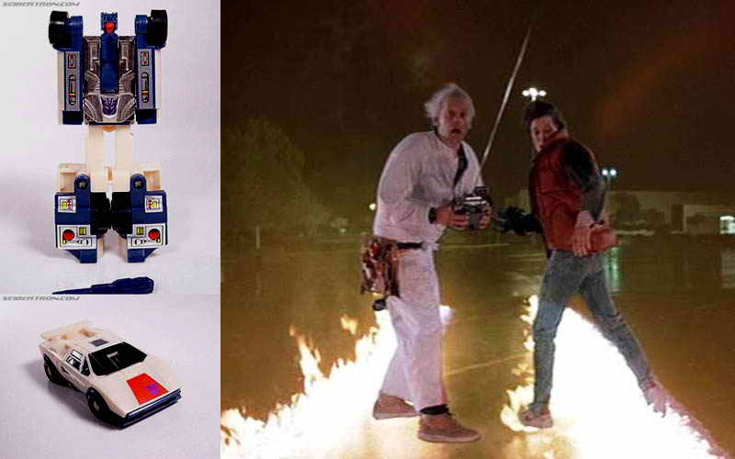
Although Dr. Brown and his lab assistant, Marty McFly, were able to achieve limited success with the phenomenon of time travel by utilizing the robot's Flux Capacitor, the bumblings of the increasingly mad doctor and his incompetent assistant led to an unfortunate incident involving 1.21 gigawatts of electricity, completely destroying all parts of the recreated robot, and nearly costing Brown and McFly their lives.

Of course, the United States government, not wanting news of the extraordinarily advanced state of its technological research and development programs to reach the ears of hostile governments, chose to enact the British paradigm of secrecy. A highly fictionalized account of the Brown incident was therefore filmed and subsequently released decades later to the American public as the movie Back to the Future. Followed by a series of two increasingly ridiculous sequel films, the government's campaign of misinformation assured that few, if any, people would ever give credence to the truths lying within the tale.

More soon to come...

MORE THAN MEETS THE EYE, PART 3

April 25, 2007

This is part 3 of a series of photojournalistic essays exposing the truth behind a worldwide government conspiracy to conceal the existence of a living, thinking robot menace from outer space.

Today's installment beings with a mystery, wrapped in a riddle, inside an enigma, which is all then dumped into a big bucket labeled "GLOBAL ROBOT CONSPIRACY." I am, of course, referring to the assassination of President John Fitzgerald Kennedy.

As soon as shots rang out at half past noon on November 22, 1963, at Dealey Plaza in Dallas, police were swarming the scene looking for the gunman who had murdered the president. However, no one but the members of an ultra-secret quasi-governmental cabal that had plotted the killing was aware that the search for a triggerman would be futile, because the shots fired at Kennedy had actually been made by a robot assassin capable of transforming itself into a long-range, high-caliber rifle of lethal accuracy.

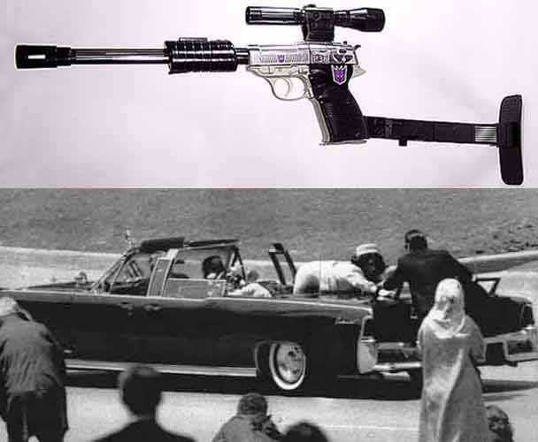

Remaining at the scene in rifle form, the robot allowed itself to be taken into evidence by authorities, who were prodded by the conspirators to arrest Lee Harvey Oswald as the fall guy for the tragedy.

Two days later Jack Ruby, another of the conspirators' operatives, broke into the Dallas Police Department's evidence locker as Oswald was on-site, awaiting transfer to a holding facility. Seizing the robot, which had now transformed into its more compact guise as a handgun, Ruby raced downstairs and shot Oswald dead, ensuring that the fact of Oswald's utter lack of involvement with the assassination would never come out at trial.
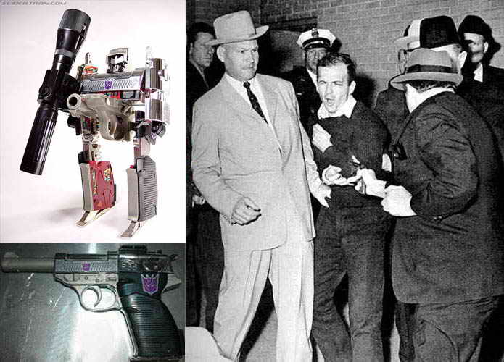

The same secret cabal that orchestrated the world-changing Kennedy assassination with the assistance of its robot allies struck again some thirty years later, in 1992. Wishing to incite a race war as a pretext for imposing martial law on the city of Los Angeles, the conspirators randomly picked an African American man named Rodney King as the winner of a fake sweepstakes offer.

For "winning" the sweepstakes, King received a high-end boom box in the mail. This quite fashionable ghetto blaster soon became King's prized possession, accompanying him everywhere he went. King was not aware, however, that his first class ticket to street creddin' and 'ho beddin' was actually a robot operative of the cabal, transformed into a portable stereo system so that it could await an opportune moment to instigate bedlam.

As King was slowly driving down the streets of L.A. one evening, cruising for some tenderoni while the boom box beside him loudly kicked out its fly beats, he passed by a number of uniformed police officers. Recognizing its chance, the disguised robot started belting out "Here, piggy-piggy!" and "You crackas got some crack, yo?" at full volume until the officers approached King's vehicle.

Once the hapless King was surrounded, the boom box proceeded to erupt in a verbal tirade against the officers so vile and disgusting that they were rendered incapable of self-control. Dragging King from the vehicle, the officers proceeded to mercilessly beat the innocent man, as the robot gleefully continued to spew its rage-inducing trash talk.

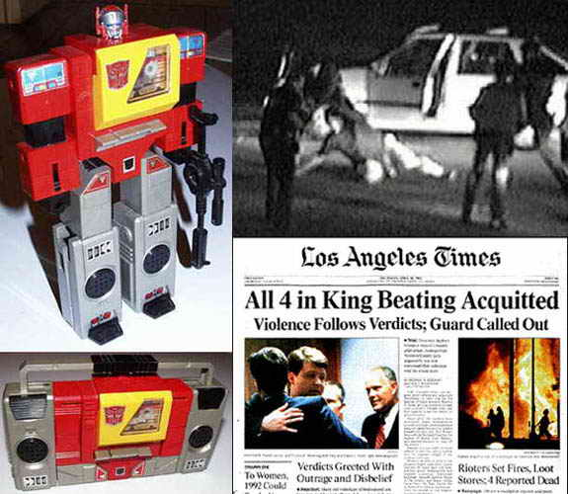
After ensuring that the event was captured on film and publicized across the nation, the cabal set up a rigged trial, designed to end in the exoneration of the policemen. As predicted, African American response to the injustice and the blatant racial prejudice of the trial sparked riots which tore through the streets of Los Angeles for several days, allowing martial law to be declared.

It is still not fully known what purpose of the conspirators was served by inciting fear and instituting military rule over the city during this period of time. However, because several children in the Rockefeller, Bush and Habsberg families all had birthdays falling very close to the dates of the riots, some believe that they were caused in order to allow the conspirators' kids to ride line-free at Disneyland in celebration of their special days.

Regardless of the rationale for the conspirators' plots, it is clear that what was originally merely a multi-governmental conspiracy to keep the public unaware of the existence of the alien robots had, by the 1960's, turned into a more refined conspiracy whereby an elite group of men sought to use the robot technology to dominate the world, and perhaps to very unfairly line-hop at popular theme parks.

More soon to come...

MORE THAN MEETS THE EYE, PART 4

April 26, 2007

Hello, and welcome to what is currently planned as the penultimate edition of my recent series of photojournalistic essays. These pieces are being written in order to expose the truth behind a worldwide government conspiracy to conceal the existence of a living, thinking robot menace from outer space.

In my last essay I suggested that the original global conspiracy designed to keep secret the existence of the robot invaders from an unsuspecting public had been seized by a power-hungry cabal that intended to use the robots and their technology for nefarious purposes.

However, although some of the robots appeared willingly, even eagerly, to assist the new breed of conspirators with whatever mysterious schemes they were trying to advance, some of the robot minions grew resentful of the cabal's control over them. It was in 1986 that the first clear hints of the deadly nature of this emerging schism were publicly revealed.

Since the late 1970's, the United States had harnessed a newly discovered breed of sentient machine to serve as a pathway to the stars. Codenamed "Project Skylynx," these machines were revealed to the public only in their transformed shape as a craft popularly known as the Space Shuttle. Pictured below to the left is a top-down view of the U.S. version of the robotic vehicle. Pictured to the right is the U.S.S.R.'s attempt at a cheap, easily breakable knockoff of the craft, which the Soviets codenamed "Project Gobot."

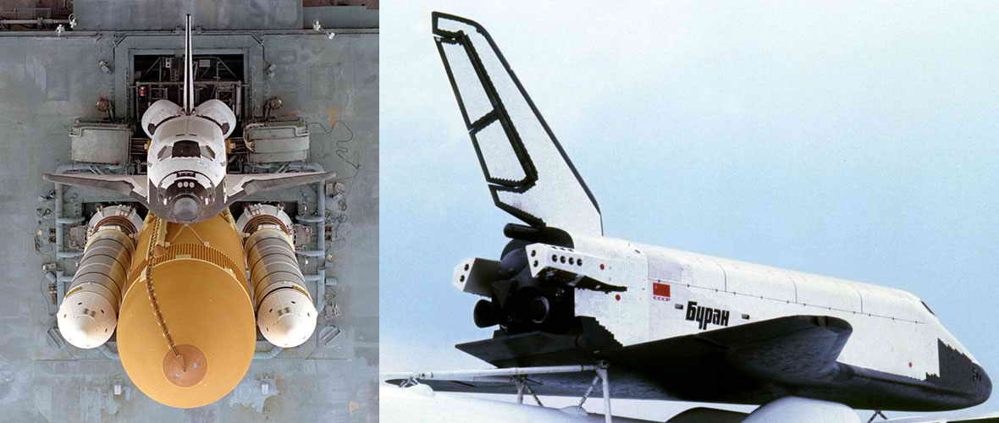

One popular misconception is that the consistent scrubbing of planned shuttle takeoffs several days prior to an actual launch is due to concerns with atmospheric and meteorological conditions. In fact, these machines are so advanced that not even a hurricane can deviate them from their launch course. Additionally, the robot vehicles are fueled by a very compact sub-nuclear core, making not only meteorological but also conventional fueling issues moot points.

So why do the shuttles we've all seen have these huge, supposedly "fuel" tanks strapped to them before liftoff? Well, that's how the cabal controls these particular tools of theirs. To get the robots to do their bidding, the cabal likes to get them entirely blitzed on an exotic concoction of refined hydrocarbons and other chemical substances, which have proven to be quite intoxicating to the alien bots.

Providing the creatures with this tasty beverage renders them very susceptible to suggestion, so the conspirators tend to strap a huge, metal Capri Sun full of the stuff to the robots before takeoff, making the robots too drunk to question commands. Once the buzz has worn off toward the completion of the space mission, the robots then become very sleepy and glide back down to Earth for a long nap, where they are recaptured by operatives of the cabal for future reuse.

Missions can only launch once the robots have had enough to drink that they move from the aggressive, surly state of intoxication into that cheerful, friendly, give-a-stranger-a-hug state. It is notoriously difficult to gauge the time this transition will take for any given robot, resulting in multiple scrubbed launches preceding any successful takeoff. The robot just wasn't hammered enough.

Well, a tragedy occurred in late January of 1986, when a robot undergoing pre-launch preparations (i.e., getting good and lit on tens of thousands of gallons of sludge shots) was mistakenly assessed by human personnel as being fit for launch. In actuality, the robot in question was by nature a particularly querulous being whose bellicose nature was severely heightened both by it getting its drunk on, and by its increasing resentment at being in bonded service to the cabal.

Being led out onto the tarmac at a point much too early in its bender, the robot decided a couple of minutes after takeoff that it'd just had enough of this shit and initiated its auto-destruct sequence, ending its miserable life along with the lives of its human crew.

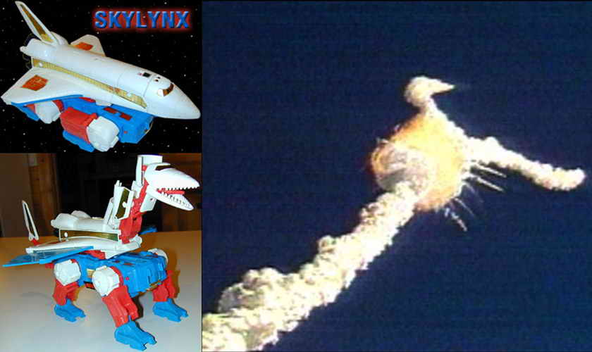
You know that old joke from the time, "What does NASA stand for?" Well, according to highly classified documents, it actually stands for "Need Another Skylynx Astrocraft." I know--how distasteful.

Although the cabal continues to use all robots still under its control, the 1986 shuttle incident sparked the beginning of a secret war between the cabal and a faction of those robots fighting for independence from the group of evil conspirators. One of the results of this war was the deployment of the AIDS virus, which the cabal originally developed using robot technology to target its human enemies of the dark-skinned or limp-wristed persuasions. Realizing that a weapon derived from the robot visitors might be the most effective defense against those very creatures, slight modifications were made to the virus, which was then unleashed against any of the robots who were uncooperative with the cabal's interests.

As it was well known to the cabal that a certain category of robots enjoyed transforming into wheeled vehicles and congregating at truck stops for the occasional orgiastic cavalcade (which, incidentally, was also the inspiration for an entire line of Japanese animated eroticism), dissemination of the destructive virus among the rebel bots was surprisingly easy, and resulted in disastrous consequences to several of the rogue machines, wasting away their powerful robot bodies to mere husks of their former glory.

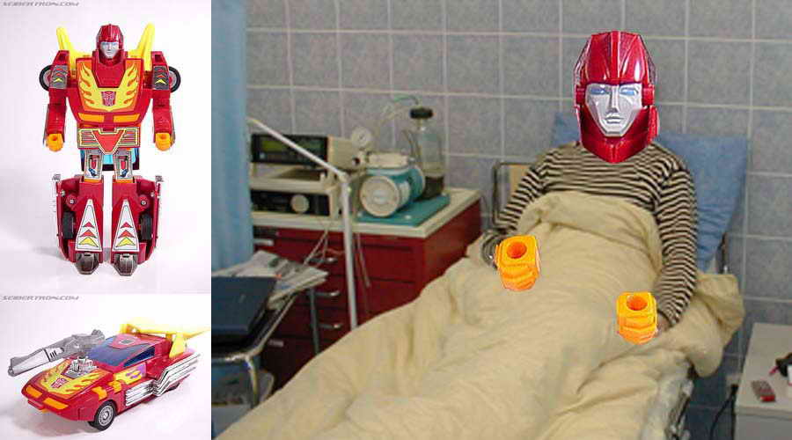
Thus the secret war between the cabal and the robots unfaithful to it continues to this day. My research on the current state of affairs regarding this momentous conflict, and my conclusions as to the current leader of the cabal and his ultimate plot for victory, will be presented in my next and last installment of this series.

More soon to come...

More Than Meets the Eye: The Conclusion

April 30, 2007

In this, the final edition of my recent series of photojournalistic essays, I conclude my efforts to expose the truth behind a worldwide government conspiracy to conceal the existence of a living, thinking robot menace from outer space.

In the early hours of April 30, 2006, a cacophonous series of explosions gave voice to the already fading glare of fireballs erupting over the horizon. Looking southward toward the distant skyline of Washington, DC, from a location just outside of Fort Meade, Maryland, an accumulating haze of dust and detritus obscured sight of the capital's distant skyline.

Then, just as the dwindling rumbles of the explosions had passed the cusp of perception, the billowing haze was slashed by the bright, oscillating lights and sharp sounds of a long line of police cruisers and other emergency vehicles racing northward along the Interstate, in hot pursuit of their quarry.

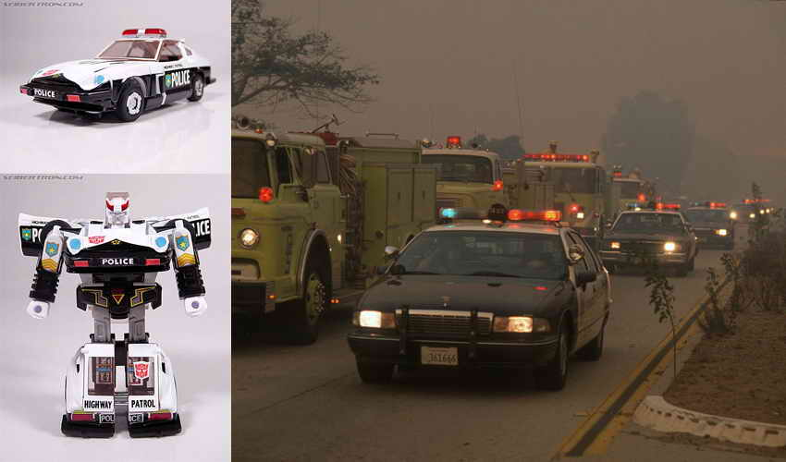
But these were no ordinary vehicles. They were actually robots in disguise, directed by their secretive Grand Master of the Cabal to hunt down and apprehend one of their own kind which had rebelled against the cabal and which was, at that very moment, headed to New York City to attempt to deliver a crippling blow against its former commander.

The leader of the robot rebellion, known among its kind as "Optimus Prime," was a powerful robot capable of transforming into the innocuous shape of a cab-over-engine design tractor-trailer rig. After years of effort by the freedom-loving rebels, Prime and its cohorts had recently discovered the Achilles heel of the otherwise seemingly invulnerable ruler of the cabal.

Having learned of a highly-publicized dinner between the Grand Master and the President of the United States scheduled to occur on the evening of April 29, Prime attempted to disguise itself with a false robotic nose that modified its transformed appearance into that of a standard long-nose cab configuration, so as to more easily slip past the multitude of robot and human sentinels at all times guarding the Grand Master.

Not wishing to engage in a battle throughout the streets of DC due to the strong likelihood of civilian casualties, Prime hunkered down for the night at a truck stop just outside the northern border of the city, waiting for the cabal's leader to pass by on his return journey at the conclusion of his conference with the President.

Adding further strain to the occasion was the fact that Prime could no longer participate in those particular pleasures that abound at truck stops across the nation, ever since the cabal's introduction of a robot-targeted version of the AIDS virus had already crippled or destroyed so many of its deeply-loved rest stop buddies, as reported in Part 4 of this series.

Although no one knows precisely how the betrayal occurred, it was at approximately sunrise on the morning of the 30th that Prime was suddenly surrounded by dozens of robots loyal to the cabal, shouting in piercing, electronic voices for Prime to surrender itself to their custody. Ramming into several banks of gasoline pumps while effecting a hasty escape, Prime looked backward to note that the ensuing explosions had incapacitated a significant number of its assailants. However, several of the attackers, transformed back into their emergency vehicle forms, continued to chase down Prime and its invaluable cargo as the rebel leader fled at top speed in the northbound lanes of I-95.

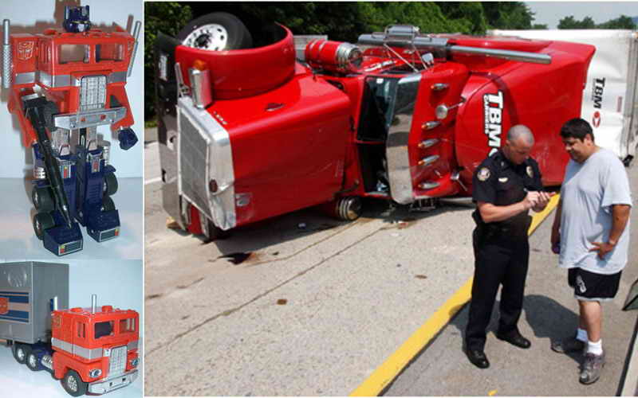
Unfortunately, due to the weight of the cargo it was hauling for intended use against the Grand Master, Prime was unable to outdistance its pursuers, and was ultimately surrounded and run off the road by robots of superior numbers and maneuverability. In its last moments of consciousness before having its life-sustaining fuel lines cut by the marauding horde, Prime unleashed the locks on its cargo compartment, praying to electronic gods to whom no human has yet bent a knee that those weapons would one day find their target.

These weapons, having long been under development by the robots of the rebellion, were a herd of assassin robots specifically programmed to transform into the one configuration capable of striking fear into the heart of the cabal's Grand Master.

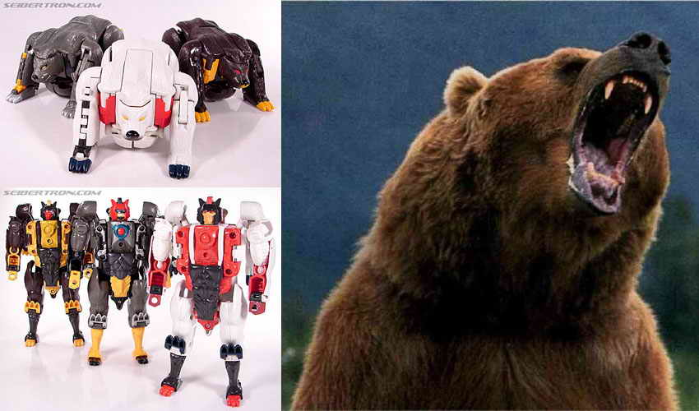
It has been exactly one year since the events noted in this article took place, and as yet I have received no intelligence confirming the destruction or the continuing existence of the rebels' ursine fighting force. In all honesty, it was only very recently that I was able to sort through enough information and disinformation to put together the pieces of the puzzle revealing the identity of the Grand Master himself.

Consider:

Who was raised in South Carolina, the site of the recent robot attack at a military air show, as related in the first edition of these articles?

Who had dinner with the President of the United States in Washington, DC, on the evening of April 29, 2006?

Who has experienced a meteoric rise in American, and worldwide, political and cultural domination ever since the events of April 29 and 30?

Who considers himself to be the Deus ex Machina, the god in the machine (and, incidentally, the god of the machines), who subtly manipulates the political ideologies of the world's greatest nation to further his own diabolical ends?

Who has created a legion of avian guardians to protect himself from any conceivable attack?

And, most tellingly...

Who is deathly terrified of bears, calling out on national television for them to be wiped out of existence on at least a weekly basis?

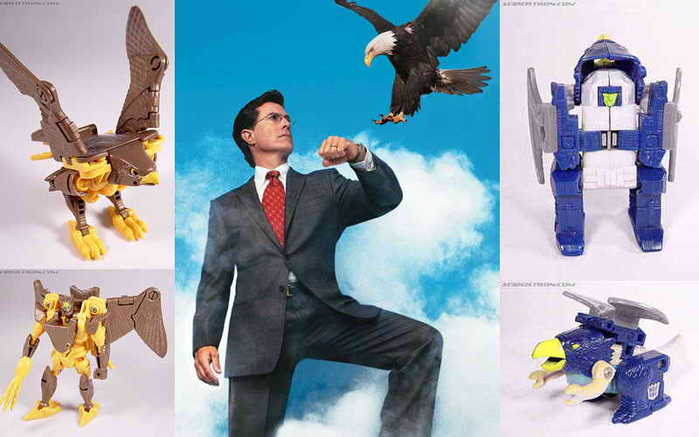
The Grand Master of the Cabal is, of course, Stephen Colbert, the world-renowned comedian, talk show host and politico, a man whose sinister secrets and almost boundless power truly make him "more than meets the eye."

Nation, protect your liberties, guard your freedoms, and clean your firearms, because the secret war between the Bears and the Eagles is rapidly heating up, and that's not just the tagline for next year's Super Bowl. This conflict is soon to boil over into the lives of all Americans, and it is time for each man, woman and child to choose sides and take a stand against Mr. Colbert and his global robot conspiracy.

Colbert...we're on to you. Consider yourself "on notice."

The End

Read more at myspace.com/bradallenthompson.

